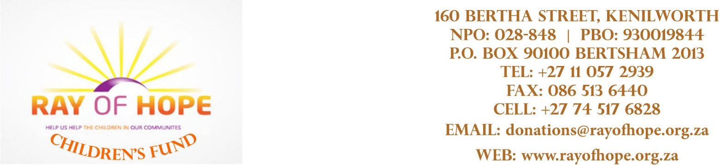

_____________________________________________________________________________________

Best among people are those who benefit mankind!!!

Att: Hamtern Financial Services

Postnet Suite 113 Ref Samson

Private Bag X21 Date 20/04/2020

Bryanston

2021

Dear Mrs Rosemary Attwell

RE: Donation s

***A miracle is something most people can only but hope for but here at Ray of hope a miracle is what we rely on. Once again we have been blessed with a miracle…..***

***Thank you!***

On behalf of management and staff I wish to convey our gratitude for your most valuable contribution to our cause. It is through the generosity of companies like yourselves and your loyal support that we are able to continue our caring service in the community.

Yours in caring

Samson Mzenda

**Samson**

**Chairman**

**0745176828/0116816273**

Trustees: SA Mzenda (Chairperson), A Malunda, MM Mabunda, S Buthelezi C Nhlapo